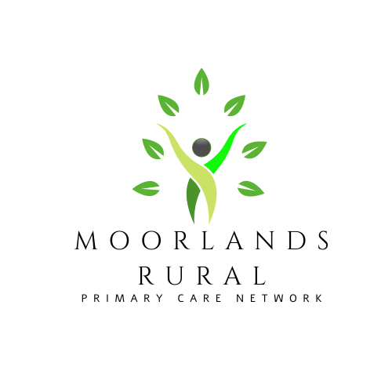
Moorlands Rural
Primary Care Network (PCN)
Practice Handbook

What are Primary Care Networks?
Since the NHS was created in 1948, the population has grown and people are living longer. Many people are living with long term conditions such as diabetes and heart disease or suffer with mental health issues and may need to access their local health services more often.
To meet these needs, GP practices are working together with community, mental health, social care, pharmacy, hospital and voluntary services in their local areas in groups of practices known as primary care networks (PCNs).
PCNs build on existing primary care services and enable greater provision of proactive, personalised, coordinated and more integrated health and social care for people close to home. Clinicians describe this as a change from reactively providing appointments to proactively caring for the people and communities they serve.
Each of the 1,250 PCNs across England are based on GP registered patient lists, typically serving natural communities of between 30,000 to 50,000 people (with some flexibility). They are small enough to provide the personal care valued by both people and GPs, but large enough to have impact and economies of scale through better collaboration between GP practices and others in the local health and social care system.
PCNs are led by clinical directors who may be a GP, general practice nurse, clinical pharmacist or other clinical profession working in general practice.
(Source https://www.england.nhs.uk/primary-care/primary-care-networks/)

What is Moorlands Rural Primary Care Network (PCN)?

- Moorlands Rural PCN are a group of practices working together to focus on local patient care
- Our PCN consists of 7 practices, with a total population of approximately 39,500
- We have a strong leadership led by our 2 Clinical Directors and supported by our PCN Business Manager
- We work collaboratively with our local GP Federation who support core General Practice and help sustain its future. The federation are facilitating and supporting the recruitment of these new roles within our Primary Care Network.

What difference does the primary care network make to patients?
- We provide care in different ways to match different people’s needs. This includes access to advice and support for ‘healthier’ sections of the population, and joined up care for those with complex conditions.
- Extra services are offered locally at each GP Practice and there is no need for the patients to travel outside of their normal GP Practice area.
- We recruit extra specialist clinical staff to work alongside existing practice staff. Including Social Prescribers, Pharmacists, Dietitians, Occupational Therapists and Physiotherapists.
- We offer improved access to services and extend the range of current services available to patients.

Our Core Values
- We will demonstrate respect and have the high standards of integrity.
- We strive for continuous improvement.
- We welcome patient engagement.

Our Vision
- To bring better health care to residents in the Moorlands Rural.
- To improve the quality of life for patients.

Our Aims
- To develop the GP practice teams and make them fit to take the NHS into the future.
- To use data, technology and local knowledge to find the best health care solutions.
- To work together to ensure that we provide good care for both patients and staff whilst
- continuing to maintain the independence and individuality of each member practic

Clinical Pharmacist

Assie O’Connor Rebecca Dear

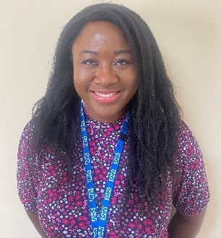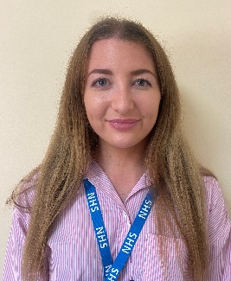

Noor Naeim Waleed Mughal

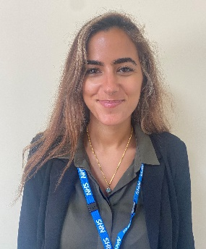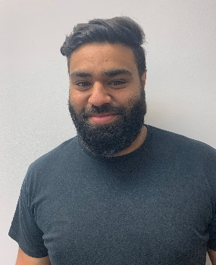

Our clinical pharmacist answers questions about the patient’s medicines and discuss how to get the best results for their health and lifestyle needs and support with:
- Medication side effects.
- Over the counter products.
- How to take different medications.
- Interactions with multiple medicines.
- Different ways to access prescriptions.

Our pharmacy team advise on medication in the local care homes too and complete Structured Medication Reviews (SMRs)

Pharmacy Technician

Jackie Alkins Alex Burton Julie Poole

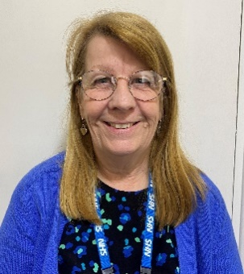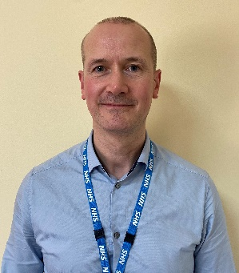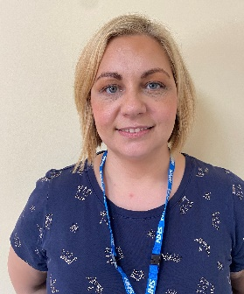

Our Pharmacy Technicians help us to identify and prioritise patients who benefit the most from speaking to our pharmacists. They liaise with community pharmacies and make the whole process of ordering and collecting prescriptions more efficient. They help reduce waste and support safety audits.

Our Pharmacy Technicians currently work on:

- DOAC reviews
- Safety Audits
- Blood Monitoring
- MHRA Alerts
- SLA / DES work
- Self-care education
- Support with DSQS audits

Social Prescribing Link Worker

Coming soon.

Our social prescribers will talk with patients to understand their needs and discuss what help and support is available. If there is a problem that is not medical, the social prescriber can connect the patient to appropriate support and find ways for them to feel more in control of their health and wellbeing and a part of the community.

First Contact Physiotherapist

Lorna Herbert

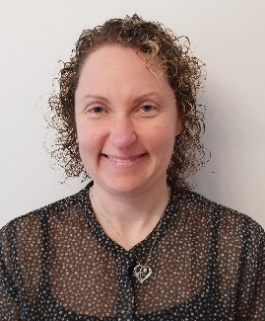

- A typical First Contact Physiotherapist appointment involves assessment, diagnosis and first line management of musculoskeletal conditions.
- This is a person-centred service, most appointments include self-management advice, social prescribing, and discussions about physical activity and fitness for work.
- We do not provide a course of physiotherapy treatment but can refer patients for a course of physiotherapy treatment if it is clinically appropriate.
- The service is only for patients aged 18+

Referral process Our First Contact Physiotherapist is:
Patients can direct access our service via their GP reception team simply by stating they have a relevant musculoskeletal condition. If any of the PCN clinicians think a patient would benefit from our input then the patient is either booked in to our diary by that PCN clinician or directed to book via their GP reception.
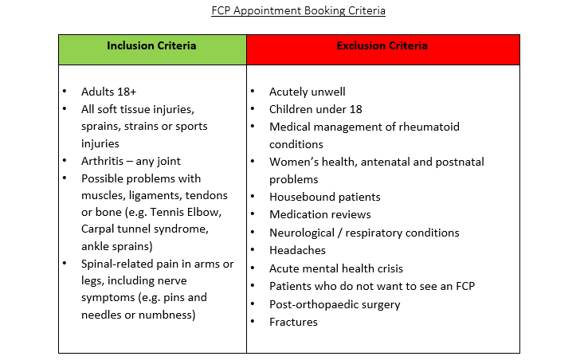
Mental Health Practitioner

Eve Homer

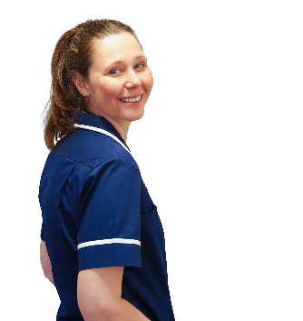

- An ageless service and is able to speak to patients with a wide range of mental health needs.
- There to support patients to access the best service for their needs, by signposting or referring patients on.
The role is to provide a non-judgmental, supportive approach to help patients gain easier access to the right service to support recovery. Patients may have a one off assessment and be signposted to other mental health services or alternatively they may be offered follow up appointments to work on short term interventions.

Support Time Recovery (STR) Worker

Diane Cox

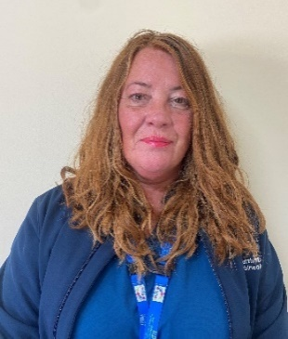

The STR supports with assessing, signposting and providing short term interventions for mental health patients. Most work will take place in the community and will be a goals based approach. The STR will work with people who may experience severe and enduring depression and anxiety, severe mental illness such as bi-polar or schizophrenia or alternatively agoraphobia or OCD, providing support in a community or home setting.

Care Co-ordinator

Nicola Bradley Abby Emery Kathy Leese

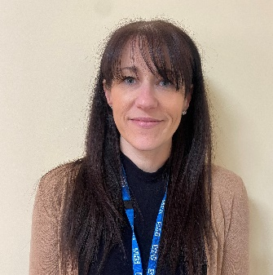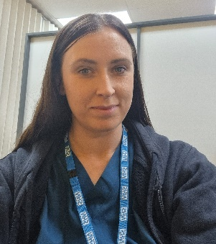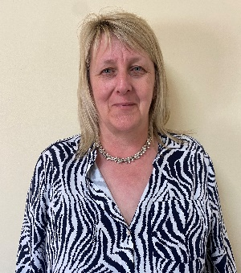

Gemma Leathem Abigail Calvert

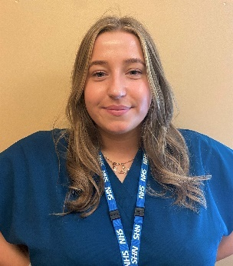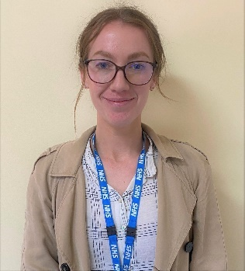

Paula Roberts

The overall aim of the Care Coordinator is to proactively identify and work with people, including the frail/elderly and those with long-term conditions, to provide coordination and navigation of care and support across health and care services.
The Care Co-ordinator ensures patient health and care planning is timely, efficient, and patient centred. The Care Co-ordinator has responsibilities for the coordination of the patient’s journey through primary care and secondary care.
This is achieved by bringing together all the information about a person’s identified care and support needs and exploring options to meet these within a single personalised care and support plan, based on what matters to the person.
Working together through a single point of access, the role will reduce and support the workload of GPs and other staff by supporting people to take more control of their health and wellbeing.

Health and Wellbeing Coach

Harriet Bree Kerri Marsh

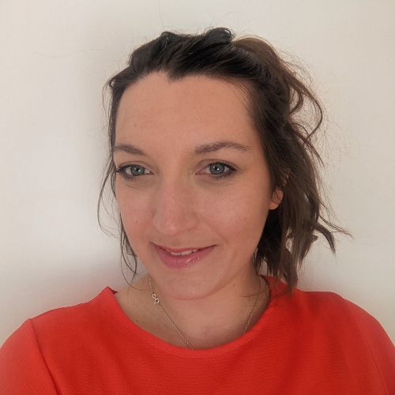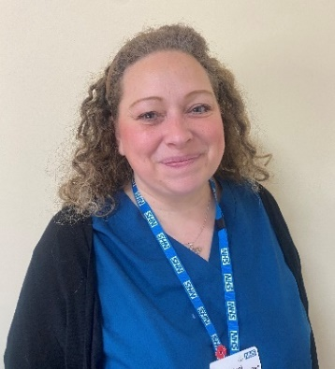

Health coaching supports patients to:
- Change their behaviour, so they can make better healthcare choices based on what matters to them.
- Supports them to become more active in their health and care.
- Develops their knowledge, skills and confidence in managing their health and wellbeing.
- Increases their ability to access and utilise community support offers.
- Encourages proactive prevention of further illnesses.
- Increases their motivation to self-manage and adopt healthy behaviours.
- Expands people’s choice and control over the care they receive.
- Improves patients’ relationships with and experiences of health care.
- Empowers people with more complex needs to support them to live well, help reduce the risk of becoming frail and minimise the burden of treatment.
- Support the patients to establish and attain self-identified goals that are important to the patient and will support their ability to manage their own health and wellbeing.
- Understands patients’ activation levels and provide tailored care and support to meet their needs.
- Support patients living with long-term conditions to access information and develop skills to find out what is right for their condition and, most importantly, right for them.
- Health coaches use general non-directive and directive coaching skills and techniques, insights and processes informed by health psychology and behaviour change science, and their own specific knowledge and skills as a practitioner to change patients’ mind-set around their health and wellbeing outcomes and encourage the onus to be with the individual.

Health and Wellbeing coaches (HWBC) provide personalised 1:1 or group session work to support patients to achieve self-identified health and wellbeing goals that will enable them to better manage and take ownership over their health concerns.

Counsellor

Kerry Simpson-Lea

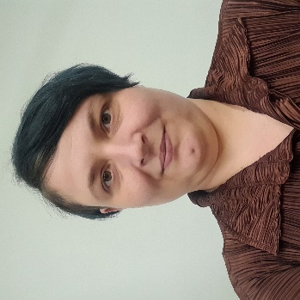

Counsellors work with clients experiencing a wide range of emotional and psychological difficulties to help bring about effective change and/or enhance their wellbeing. All sessions are held in a safe and confidential environment.

Our Counsellor can support people who are experiencing depression, anxiety, stress, loss and relationship difficulties that are affecting their ability to manage life. Clients are encouraged to look at their choices and find their own way to make a positive change in their life.

Physicians Associate

Sian Wiseby Marcus Williamson
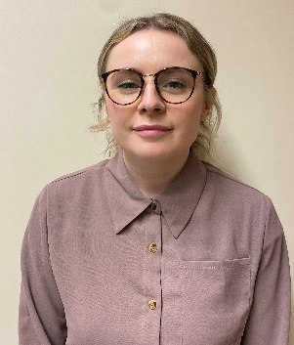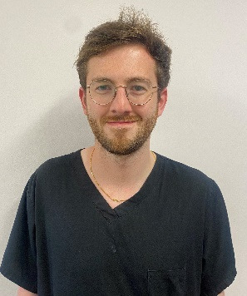
Sharon Laver Ariane Arevalo

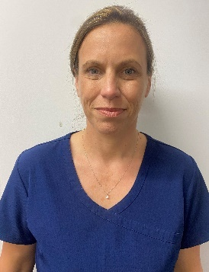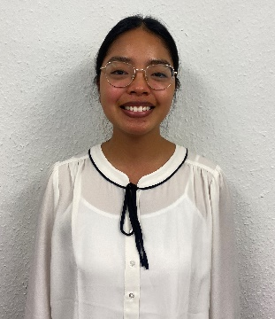

Physician associates are medically trained, generalist healthcare professionals, who work alongside doctors and provide medical care as an integral part of the multidisciplinary team. Physician associates are practitioners working with a dedicated medical supervisor (s), but are able to work autonomously. All physician associates have a background degree in a health care science for example Bio-med, Physiotherapy, Radiology/radiotherapy etc., then go on to complete a post graduate physician associate qualification.

What do physician Associates do?
Physician associates work within a defined scope of practice and limits of competence. They:
- Take medical histories from patients
- Carry out physical examinations
- See patients with undifferentiated diagnoses
- See patients with long-term chronic conditions
- Formulate differential diagnoses and management plans
- Perform diagnostic and therapeutic procedures
- Develop and deliver appropriate treatment and management plans
- Request and interpret diagnostic studies
- Provide health promotion and disease prevention advice for patients.

Trainee Nursing Associate / Nursing Associate

Grant Ridgeway Michelle baker

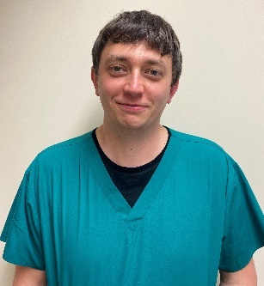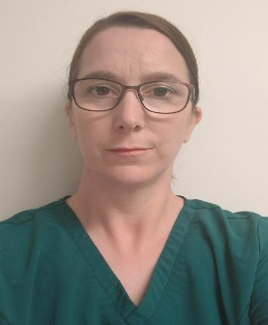

The Nursing Associate and Trainee Nursing Associate is a support role that bridges the gap between healthcare support workers and registered nurses to deliver hands-on, person-centred care as part of the nursing team. Nursing Associates work with people of all ages in a variety of settings in health and social care, including general practice.
The role was introduced in response to the Shape of Caring Review (2015), to help build the capacity of the nursing workforce and the delivery of high-quality care. It will be a vital part of the wider health and care team and aims to:

- support the career progression of healthcare assistants
- enable nurses to focus on more complex clinical work
- increase the supply of nurses by providing a progression route into graduate-level nursing

OUR MANAGEMENT AND SUPPORT TEAM & GP PRACTICES

Our PCN Management Team

Karen Cartlidge Dr Usha Tiguti Dr Anand Garlapati
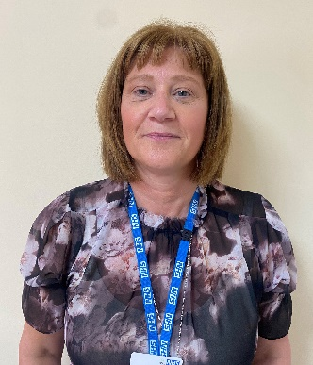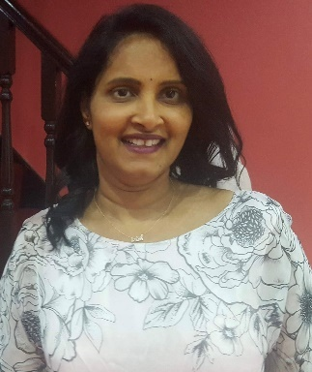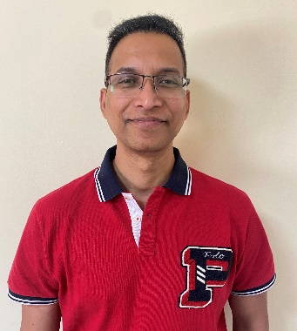

Business Manager Clinical Director Clinical Director
+ Digital Transformation Lead

Moorlands Rural PCN Facebook page

https://www.facebook.com/MoorlandsRuralPrimaryCareNetwork

Our GP Practices

Allen Street Clinic
Tel: 01538 752674 www.allenstreetclinic.com

Allen St, Cheadle, Stoke on Trent, ST10 1HY
Well Street Medical Centre
Tel: 01538 753114 www.wellstreetcheadle.nhs.uk

Well St, Cheadle, Stoke-on-Trent, ST10 1EY
The Tardis Surgery
Tel: 01538 753771 www.tardissurgery.co.uk

Queen St, Cheadle, Stoke-on-Trent, ST10 1BH
Werrington Village Surgery
Tel: 01782 304611 www.werringtonsurgery.nhs.uk

Ash Bank Rd, Werrington, Stoke-on-Trent, ST9 0JS
Tean Surgery
Tel: 01538 722323 www.teansurgery.co.uk

Old Rd, Tean, Stoke-on-Trent, ST10 4EG

Blythe Bridge Health Centre
Tel: 0300 1234017 www.teansurgery.co.uk

Uttoxeter Rd, Blythe Bridge, Stoke-on-Trent, ST11 9NT
Alton Surgery
Tel: 01538 704200 www.altonsurgery.nhs.uk

Hurstons Ln, Alton, Stoke-on-Trent, ST10 4AP
Waterhouses Medical Practice
Tel: 01538 308207 www.waterhousesmedical.co.uk

Waterfall Ln, Waterhouses, Stoke-on-Trent, ST10 3HT

